**Unit 3 Worksheet 1b**

**Uniform Acceleration**

|  |  |
| --- | --- |
| *t* |  |
| (s) | (cm) |
| 0.0 | 0.0 |
| 1.0 | 5.0 |
| 2.0 | 20.0 |
| 3.0 | 45.0 |
| 4.0 | 80.0 |
| 5.0 | 125.0 |
| 6.0 | 180.0 |

1. In the table at right are position-time data for a wheel rolling down a track.

To save time, the graph of x vs. t has been plotted for you.

200

175

150

125

100

75

50

25

0 1 2 3 4 5 6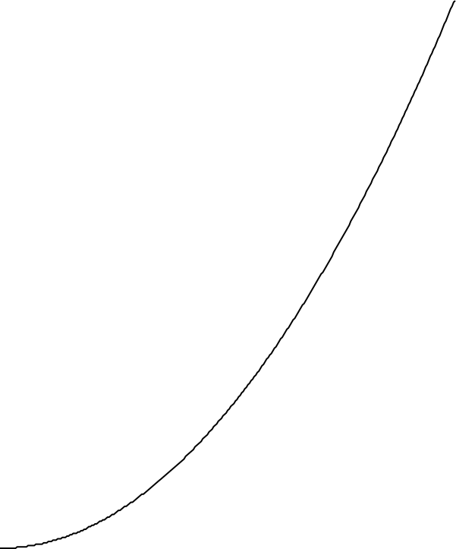

Time (s)

Position (cm)

0 1 2 3 4 5 6

time (s)

1. For each 1.0 s clock reading (1.0 s to 5.0 s) draw, in a different color, a line (secant) connecting the point before and the point after. What is the physical significance of the slope of each of these lines?
2. For each of the lines you have drawn, calculate the slope. Pick the two points on the line. Record the coordinates of each point. Use these coordinates to calculate the slope. Show your work including the equation for the slope.

|  |  |
| --- | --- |
| For t = 3.0 s copy your work from WS 1a | t = 3.0 s |
| *t* = 0.0 s (Since no line could be drawn, estimate the value you believe to be most probable…) | t = 4.0 s |
| t = 1.0 s | t = 5.0 s |
| t = 2.0 s | t = 6.0 s (Since no line could be drawn, estimate the value you believe to be most probable…) |